THE UNIVERSE AS EXPERIENCE
A personal metaphysical theory
ᛃᚨ
This is not presented as a scientific theory or as a claim about objective reality. It is a personal metaphysical and spiritual framework: a way of imagining what God, consciousness, existence, knowledge, and human life might mean if our usual assumptions about the universe are incomplete.

1. The Beginning: Creation Without Complete Understanding
I imagine that there is a being—or something beyond what we currently understand—that created the universe. I do not imagine creation necessarily as a human-like act of planning every detail. It could be more like a mechanism: a button, a system, an unknown process. Something was activated, and the universe came into existence.
The strange part is that the creator may not completely understand what happened. The creator has enormous power over the universe: it may be able to alter things, create things, accelerate or reverse events, or observe any part of existence. Yet power over a system is not necessarily the same thing as understanding the system.
A creator could be like someone sitting inside an enormous machine full of controls. The controls work. The machine responds. But the person does not necessarily know how the machine was ultimately built, why it behaves exactly as it does, or whether something else created the machine before them. The creator may have forgotten, may never have known, or may itself be part of a larger reality.

2. The Universe as an Endless Living Process
The universe is not merely a static object. I imagine it as an enormous process that is always unfolding. It resembles a video that can be moved forward and backward, except that there may be no final frame.
The creator can look at one place and observe its history. Earth can be examined from its beginning through the development of life, civilization, and whatever comes afterward. The same can be done with stars, galaxies, black holes, planets, particles, and forms of life that we have not yet discovered.
There is no reason within this idea to assume that Earth is the center of existence. Human beings are one local form of life inside an enormous reality containing countless other processes and perhaps countless other forms of experience.

3. The Creator Enters the Creation
At some point, the creator decides that observing the universe from outside is not enough. If the creator wants to understand the universe, it must experience the universe from within.
So the creator creates another mechanism: a way to enter existence itself. It can become part of the universe without necessarily retaining conscious knowledge of being the creator.
It does not have to become only a human. It could enter a human, an animal, a plant, a piece of matter, a body of water, a star, a shadow, a planet, or something so fundamentally different from human experience that we currently have no language for it.
The purpose is not to give these things supernatural power. The purpose is experience.

4. The Fragmentation of Experience
The creator places a part of itself into everything. Each individual existence receives a perspective, but that perspective is isolated from the totality.
Imagine watching a film through an impossible form of virtual reality in which you can simultaneously experience every object, every location, every organism, every particle, and every event—but each experience feels independent. The creator no longer remembers that all of these perspectives belong to the same underlying being.
A human therefore experiences life as a human. A black hole experiences existence in a way that may be completely inaccessible to us. A star has its own physical history. A molecule has its own existence. Whether these things possess consciousness in any sense we recognize is unknown. The theory does not require them to think like humans. It only requires that existence contains forms of experience that the creator can eventually learn from.

5. Every Life Has an End
Nothing within the universe needs to last forever. Every form has a beginning and an end.
A human life ends. A star dies. A structure breaks apart. A black hole eventually changes or disappears. Matter and energy move through different forms. The individual experience therefore has a boundary.
When an experience ends, whatever was experienced eventually returns to the larger being. I do not know exactly how this happens, or whether it happens immediately. I imagine it as knowledge returning from the countless perspectives through which the creator has lived.

6. Knowledge Through Experience
The creator is not simply collecting facts. It is collecting perspectives.
A human can learn what it feels like to love, lose, create, fear, discover, suffer, laugh, paint, sing, touch another person, look at the night sky, or solve a problem. Another form of existence may provide an experience that a human could never have.
The creator may therefore acquire not only intellectual knowledge, but sensory, emotional, spatial, temporal, physical, and other kinds of knowledge that we do not yet understand.
Every life contributes something because no two experiences are exactly identical. Even if two people live similar lives, their perspectives are different. Every existence therefore has the possibility of adding something new.

7. Humanity Is Not the Center
Human beings are animals that emerged from the physical history of this planet. We are not necessarily the purpose of the universe.
At the same time, humans create things that resemble miniature acts of creation. We build computers, engineer organisms, manipulate DNA, construct artificial environments, and create systems whose behavior can become more complicated than we anticipated.
This creates a scale of creation. We can be creators relative to something below us while remaining creations relative to something above us. There may always be another level: below cells, below molecules, below atoms, below particles; above humans, above planets, above stars, above galaxies, and perhaps above whatever we currently consider the highest level.
The hierarchy may never end.

8. The Creator Does Not Know the Final Answer
The creator's ultimate question may be the same question humans ask:
How did I create all of this?
Perhaps the creator knows that it initiated the universe but does not understand the mechanism completely. Perhaps something existed before it. Perhaps another being created it. Perhaps there is another level above it. Perhaps the creator itself is part of an infinite chain.
The theory does not require a final answer. In fact, the absence of a final answer is part of the theory. Every discovery can reveal another question.

9. God as a Researcher
Under this view, God is not merely an all-knowing observer. God is also a researcher.
The universe becomes the research environment. Life becomes the method of observation. Conscious beings become instruments through which new perspectives are generated.
When humans discover a new law of physics, the creator gains that perspective. When we discover a black hole, the creator learns something about black holes. When we travel into space, create new technology, understand genetics, or uncover something about consciousness, the total body of experience expands.
The creator may learn faster than any individual human because it receives experience from many forms of existence. But it does not necessarily experience every perspective in the same way. A human experience is valuable precisely because it is a human experience.

10. Religions as Human Attempts to Understand the Same Mystery
Religions may be humanity's attempts to interpret the possibility that existence contains something greater than ordinary individual experience.
Different cultures may have encountered different aspects of the same underlying mystery, or they may have developed completely independent explanations. This theory does not decide which interpretation is correct.
There could be truth in Christianity, Norse mythology, Hindu philosophy, Buddhism, Islam, Judaism, indigenous traditions, or traditions that have not survived. There could also be truth in none of them, or pieces of truth distributed across many traditions.
A religious story could be literally true, metaphorically true, historically transformed, or entirely human-made. The theory leaves room for uncertainty.

11. Sacrifice, Knowledge, and the Divine
This is where the story of Odin becomes personally significant.
In the Hávamál, Odin sacrifices himself upon the cosmic tree in order to gain knowledge of the runes. He wounds himself, remains suspended for nine nights, and emerges with knowledge that he did not possess before.
The structure is striking: the divine enters limitation, undergoes suffering, obtains knowledge, and returns transformed.
Christian theology contains a different but structurally comparable idea in the incarnation and suffering of Christ: the divine enters human existence and undergoes death in connection with the salvation of others.
Some Hindu philosophies provide another conceptual framework in which ultimate reality and individual experience are related through manifestation, ignorance, realization, and return.
These traditions are not identical, and this theory does not claim that they secretly tell the same story. The point is that they can be compared through a recurring structure: divinity, limitation, experience, transformation, and return.

12. Jera and Ansuz — ᛃᚨ
The two runes that inspired this theory are Jera and Ansuz.
Jera carries the symbolic field of year, cycle, harvest, fruition, good season, and the result of what has been cultivated.
Ansuz carries the religious and symbolic field of a god or divine being, and in later rune traditions is connected with speech, wisdom, divine knowledge, and Odin.
Together, they can be interpreted personally as:
- Divine harvest
- Harvest of wisdom
- Wisdom made manifest
- Divine knowledge bearing fruit
- The cycle of divine experience
- Experience returning as knowledge
- Creation becoming understanding
- The divine learning through creation
The strongest personal interpretation is not a historical translation of the runes. It is a symbolic statement created from them:
THE DIVINE HARVEST OF EXPERIENCE

13. Life Under This Belief
If this view is true, human life does not need to have a predetermined purpose for it to have value.
We may not know why we exist. We may not know whether there is a plan. We may not know whether God exists in the form imagined here, whether another creator exists above God, or whether there is an entirely different explanation.
That uncertainty does not make experience meaningless. It makes experience the one thing we actually possess.
We live. We experience. We create. We discover. We learn. We suffer. We love. We investigate the small and the enormous. We try to understand what made us while simultaneously becoming part of the evidence from which that understanding might eventually emerge.
If the creator is experiencing the universe through us, then our discoveries become part of the creator's discovery. If there is no creator, the experiences still happened. Either way, the act of living and learning remains real from within the life being lived.

14. The Final Question
Perhaps the universe is a creation. Perhaps it created itself. Perhaps something created the creator. Perhaps there is an infinite hierarchy of realities. Perhaps there is no hierarchy at all.
There may never be a final answer available to us.
But the search itself may be part of the structure.
We discover the universe because we live inside it.
The universe discovers itself through everything that exists within it.
And perhaps God discovers God through the universe.

Personal note: This document records a metaphysical belief and imaginative framework. It is intentionally open-ended and should not be mistaken for an empirically established description of the universe.

15. My Part of the Story
This is my part of the story now. This is what I believe, and this is what I want my own life to become within this larger idea.
I am an artist. My story begins with painting. When I was younger, there were emotions inside me that were difficult to understand, organize, or explain. Painting became a way to receive those emotions, transform them, and put them somewhere outside myself. The paintings began as records of my inner life: attempts to understand what I was feeling by giving those feelings physical form.
Over time, I imagine the paintings changing. They become less like isolated artworks and more like a long-term record of a mind moving through time. In that sense, I want the body of work to become something like an artificial intelligence journal: a visual archive of how a human being thinks, feels, changes, remembers, and interprets existence.
I imagine eventually having a hundred paintings, or perhaps more. Each one becomes another piece of the record. I want to finish them all. The completed collection would not simply be a portfolio. It would be a history of one consciousness moving through a lifetime.

The Black Lotus
During that journey, my appearance changes alongside the work. I begin wearing black. At first it is simply clothing, but gradually it becomes a visual language.
The clothing develops a sharp, petal-like neckline, influenced by kimono construction and the geometry of leaves. At first the shape is subtle: a dark structure beneath or around ordinary clothing. Over time, it becomes larger, more deliberate, and more architectural.
The silhouette begins to resemble the opening of a lotus flower.
The same fundamental shape remains even as the clothing changes. Sometimes it is small. Sometimes it becomes exaggerated. Eventually the entire garment can take on the character of a lotus: layered, sharp, symmetrical, and unmistakably black.
The clothing becomes part of the artwork. It is no longer merely something I wear. It is another evolving record of the person I am becoming.

Black Becoming White
As I grow older, the black begins to change.
The transformation is gradual. Black becomes less absolute. The upper part of the clothing begins to fade toward grey, then toward white. The lotus remains, but its color changes.
The older I become, the more the flower loses its darkness. Eventually the lotus becomes white.
In old age, I imagine myself wearing elaborate, almost imperial robes: large, formal, sculptural garments built around the same lotus geometry that began as a small detail in ordinary clothing.
The shape remains recognizable across the entire lifetime. What changes is the color.
Black lotus → fading lotus → white lotus
The black represents the beginning: the unknown, the unresolved, the emotional material that I am trying to understand. The gradual movement toward white can represent age, knowledge, integration, clarity, or simply the accumulation of experience. I do not need to decide exactly what the color means. The transformation itself is the meaning.
Eventually, I die.
The clothing ends with me. The paintings remain.

The Name
One possible artistic name within this evolving story is built around Han and Andrade.
HAN · ANDRADA
The idea is not necessarily to keep the literal form “Han Andrade.” I am interested in combining HAN with ANDRADE through a small mark or symbol so that the two parts visually merge into a single name.
HAN · ANDRADA → HAN’DRADA
The resulting sound and spelling can evolve. The important part is keeping HAN as a recognizable piece of the name while allowing the connecting symbol to become part of the identity. The final form can change later; the concept does not need to be fixed now.

A Lifetime as a Single Artwork
The paintings, the symbol, the clothing, and the name can therefore become parts of the same long narrative.
The paintings document the inner experience. The symbol condenses the philosophy. The clothing makes the philosophy visible on the body. The name identifies the person carrying it through time.
The black lotus begins as an image of what I cannot yet understand. It grows as I grow. It becomes more elaborate as the archive of paintings becomes larger. Eventually it fades toward white as the person carrying it becomes old.
The story does not claim that I know what happens after death. That remains unknown. Within the larger theory, however, death is not necessarily the destruction of experience. It may be the point at which one perspective ends and whatever has been experienced becomes part of something larger.

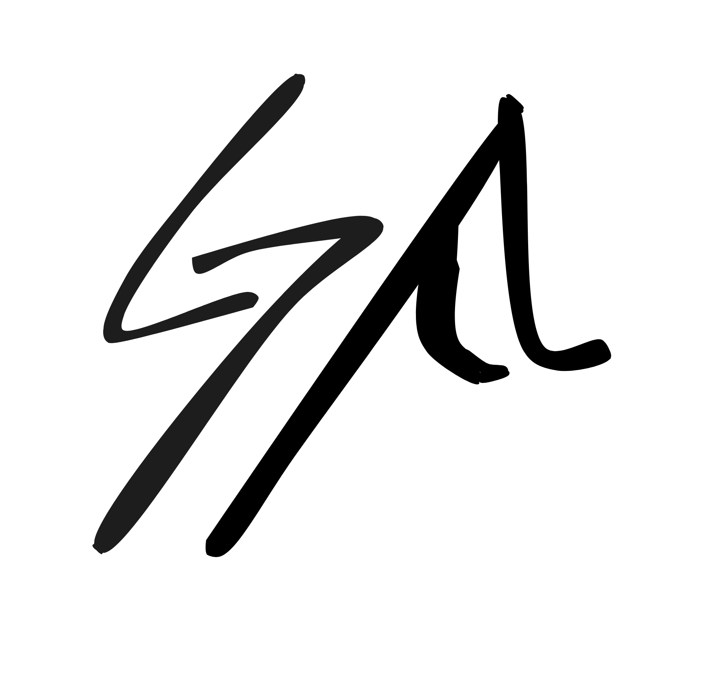
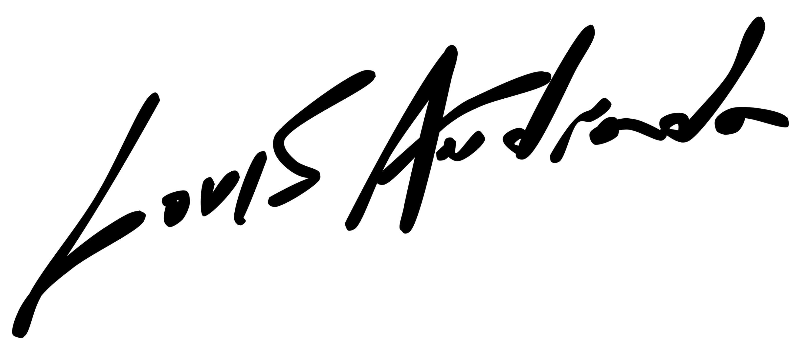
I do not know what the universe is.
I do not know what God is.
I do not know what happens after death.
I only know that I am here, that I can experience,
that I can create, and that I can leave something behind.

